Project Report


Real time Flight Management System in C++
Submitted to:
Prof. Muhammad Faisal Idrees
Department of Computer Sciences
2024 CS-B

Made by:
- Rasba Mazhar (243571)
- Eisha Asim (243575)
- Saleha Khurram (243529)

Introduction: 3
Overview: 3
Problem Statement: 3
Objectives: 3
Scope: 3
Included Features: 3
Limitations: 3
Significance: 4
Methodology: 4
Programming Environment: 4
Tools and Libraries: 4
Standard Template Library (STL): 4
Libraries: 4
System Design: 5
Approach: 5
Logic: 5
Algorithms: 6
Innovative Aspect: 6
Project Modules: 6
Welcome Menu: 6
Details Taken: 6
User Accounts 7
Passenger’s Interface: 8
Flight Search and Availability: 8
Booking Management: 8
Check Flight Status: 9
Boarding Pass Generation: 9
Cancel Booking: 10
Admin’s Interface: 10
Menu: 10
Add Flight: 10
Update a Flight: 11
Delete a Flight: 11
Manage Seat Availability: 12
Send Confirmation Email: 13
Conclusion and Future Work 13

Introduction:

Overview:
Flight Reservation System is designed to make the process of booking and managing flights easy for passengers and airline admins. This project addresses common challenges such as user management, seats availability, generating tickets and boarding pass, booking, modifying and canceling reservations.

Problem Statement:
Handling booking management manually can be inefficient and can contain errors because it is managed manually by a human but relying on a computer software can make things easier for airline and passenger. So, there’s a need for a system that can manage bookings and reservations and provide a user-friendly interface for both passenger and airline admins.

Objectives:
- To develop a reliable Flight Reservation System for both passenger and airline admin.
- Enable the user to easily book a flight and check status of that flight.
- Enable user to modify and cancel reservations.
- Enable admin to add flight, update flight and delete a flight.
- Store user information in files securely.
- Provide a user-friendly interface for both passenger and airline admin.
- Make sure user and admin authentication.

Scope:

Included Features:
Searching available flights, flight booking, check flight status, handle seat availability, generate boarding pass, modification, cancellation of reservations and shows a confirmation email message.

Limitations:
- The system will not include real-time flight updates.
- Third-party integrations (e.g., payment gateways) are not implemented in this version.
- Available seats don’t get updated.
- It doesn’t generate real boarding pass, it just provides a layout of it and it also doesn’t get stored.
- Confirmation emails are not officially sent. Just a message is displayed that "Confirmation email has been sent to the Passenger".

Significance:
- Provides accurate availability of flights and seats.
- Facilities users to book a flight at their own ease, anywhere and anytime.
- Generate tickets and boarding pass.
- Enables user to modify and cancel a flight.
- Provides with information about available seats.
- Enables admin to add, update and delete a flight.
- Provides with pricing information.
- Ensure a secure environment protecting sensitive information of passenger and admin.

Methodology:

Programming Environment:
- Integrated Development Environment (IDE): Dev C++
- Compiler: GCC (MinGW)

Tools and Libraries:

Standard Template Library (STL):
- Algorithms: Functions for operations like sign up, log in, searching, booking, seat availability, canceling and modifying flight.
- Iterators:
  - Input Iterators
  - Output Iterators
  - Index-based iterators

Libraries:
- User Input/Output: Libraries to handle input and output operations.
#include<iostream>
- File Management: Tools for managing files, paths, and directories.
#include<fstream>
- Random Number Generation: Generates random number through rand ( ) function.
#include<cstdlib>
- Time Management: Used to add functionality of time (0) and time_t to deal with current time.
#include<ctime>

System Design:
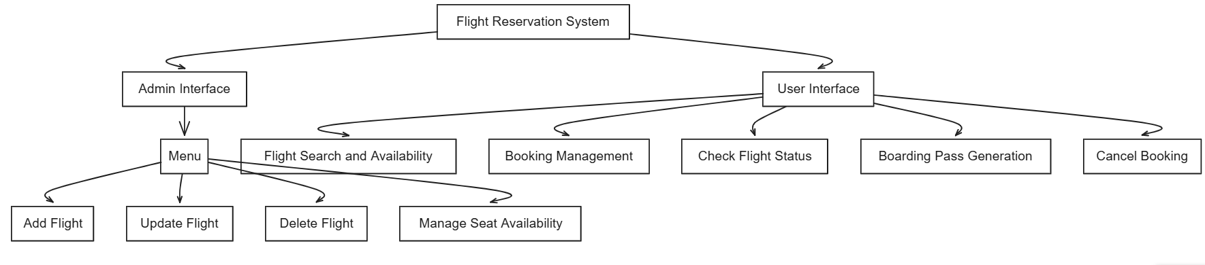

Approach:

Logic:
- User Registration and Authentication:
  - Users can create accounts and log in to access the system.
  - Secure handling of user credentials with basic validation checks.
- Flight Search and Availability Check:
  - Users input search criteria like destination, date, and time.
  - The system searches through the flight database to find matching flights.
  - Check for seat availability on selected flights.
- Booking Process:
  - Users select a flight and proceed to book seats.
  - The system verifies seat availability and allocates seats.
  - Booking details are stored, and a confirmation is sent to the user.
- Modification and Cancellation:
  - Users can modify or cancel existing bookings.

Algorithms:
Search Algorithm:
- Purpose: Find available flights based on user criteria.
Booking Algorithm:
- Purpose: Allocate a seat to the passenger and confirm the booking.
Cancellation Algorithm:
- Purpose: Handle the cancellation of a booking and update seat status.
Seat Availability Check:
- Purpose: Check the availability of seats on a flight.

Innovative Aspect:
Our program is unique because it is developed using arrays and functions without incorporating classes, showcasing an innovative and minimalist coding style.

Project Modules:

Welcome Menu:
It displays a welcoming message and shows a menu if you want to enter as an admin or passenger.
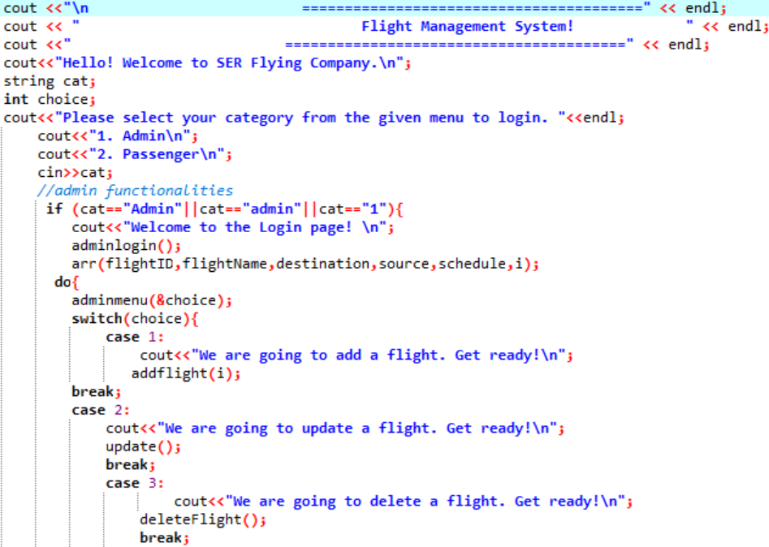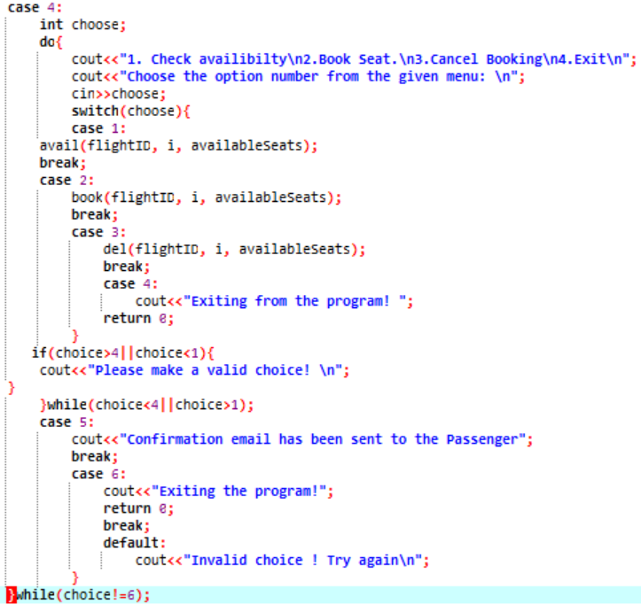
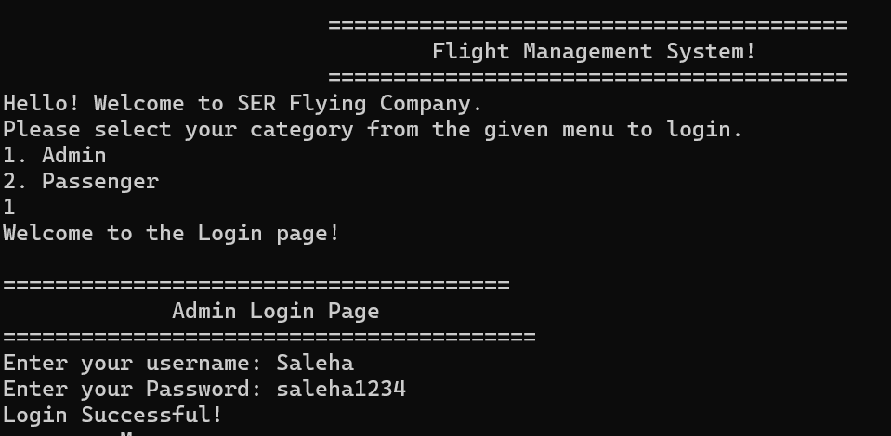

Details Taken:
- Function: main ( ),FlightNames ( ), availableFlights ( ), Sources ( ), Destinations ( )
- File Handling: File name is “details.txt”
Process:
- In main ( ) function, after welcoming the user , it prompts to ask you’re his information such as his name, Flight ID, Flight name, Flight source and destination and the seat he wants.
- The above files are used to display Flight names, Flight IDs,Flight source and destination.
- This information is then stored in “details.txt” file through file handling.
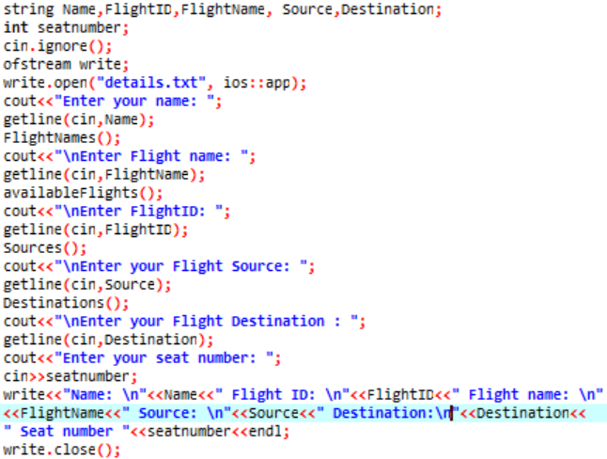
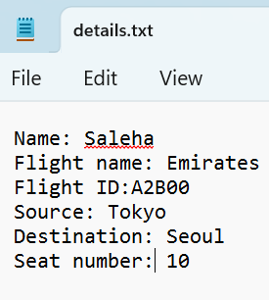
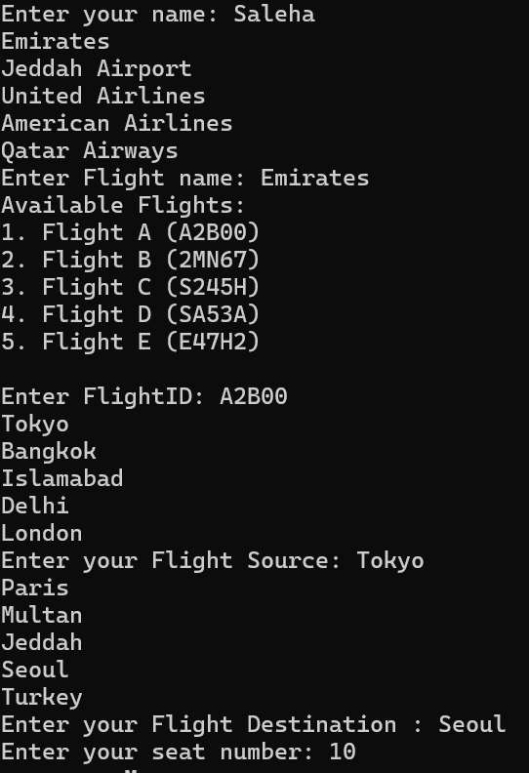

User Accounts

Signup Page:
Purpose: Allows passengers to signup if they are first time users by entering username and password they want to set.
- Function: passlogin ()
- File handling: file name is “passenger.txt”
Process:
- In passlogin ( ) function, it prompt the user to ask if they are first time user (0) or not (1).
- If he selects 0 for first time user, the username and password he wants to set is asked.
- Then this username and password is stored in “passenger.txt” file through file handling.
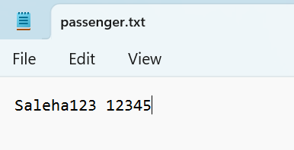

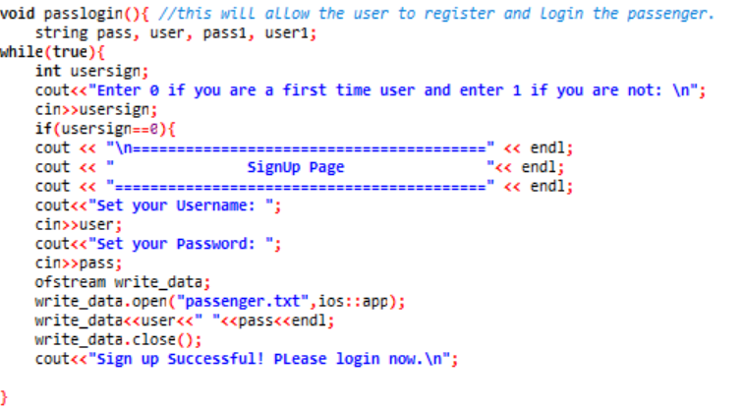
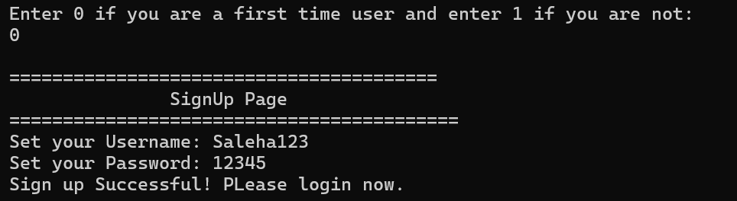

User Account:
Purpose: Allows passengers to log in by entering the data they provided in sign up.
- Function: passlogin ( )
- File Handling: File name is “passenger.txt”
Process:
- After user selects 1 for showing that he is not first-time user, it prompts to ask username and password
- If this information matches with information in “details.txt” then he is logged in and a menu is displayed.

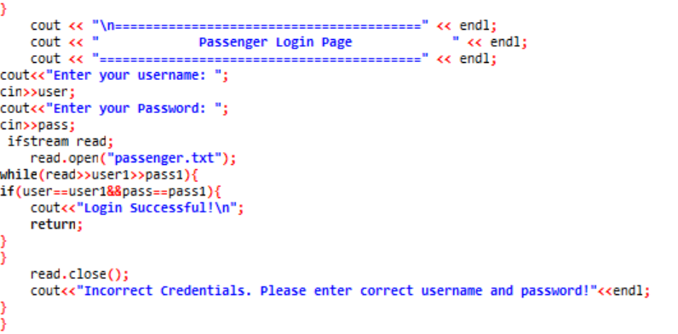
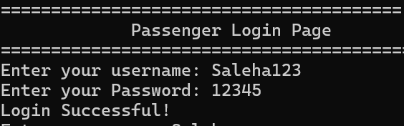

Admin Account:
Purpose: Provides administrators with a secure portal to manage system operations.
- Function: adminlogin ( )
- File Handling: File name is “admin username password”
Process:
- We have stored sample details in “admin username password” file
- It prompts to ask user username and password, if this data with “admin username password” file data, admin is logged in and shown a menu.
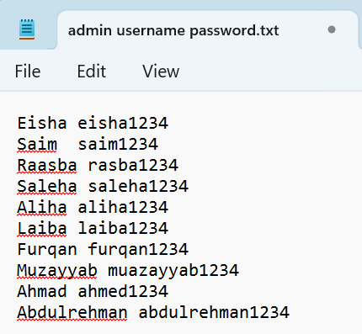
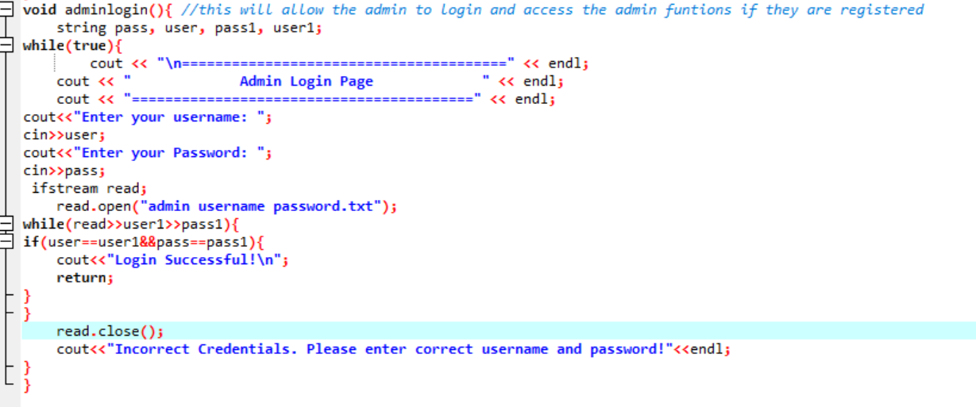


Passenger’s Interface:
Menu:
cout<<"1. Search Flights and Flight Details\n";
cout<<"2. Book Ticket\n";
cout<<"3. Check Flight status\n";
cout<<"4. Generate Boarding Pass\n";
cout<<"5. Cancel Booking\n";
cout<<"6.Exit\n";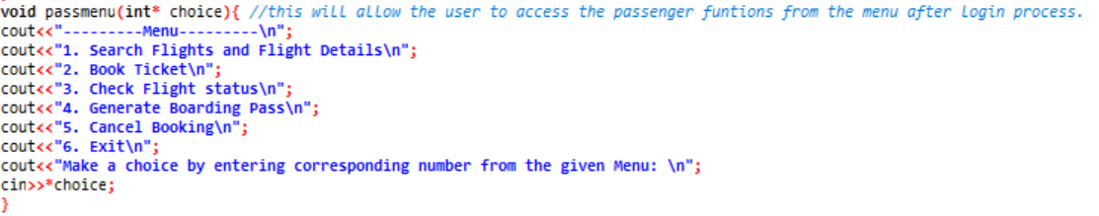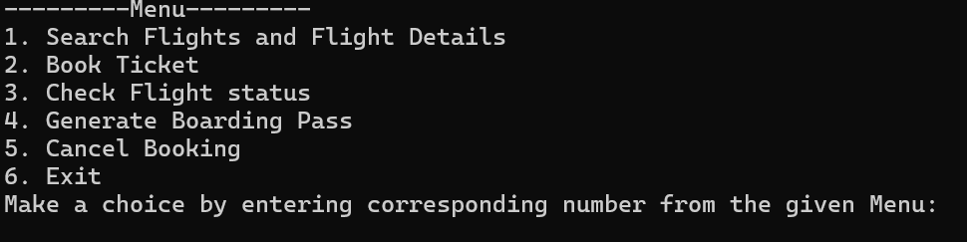

Flight Search and Availability:

Purpose: Search flights by FlightID and it will give the whole details of the respective flight.
- Function: search ( ),availableFlights ( ),time (0),rand ( )
- Arrays: flightID [],schedule[a]
Process:
- We displayed Flights and FlightIds through a function availableFlights ( ).
- In search ( ) function, it prompts to ask user to enter FlightID of the flight he wants to check.
- When he enters FlightID, if it matches with the flights in our array then it gives details of the required flight.
- Also, we used time (0) and time_t to display current time.
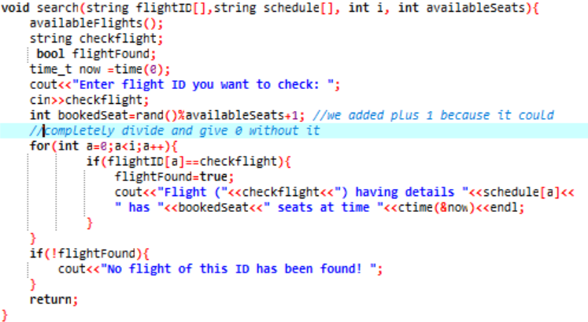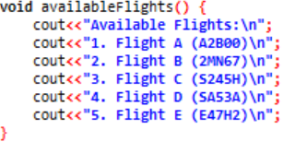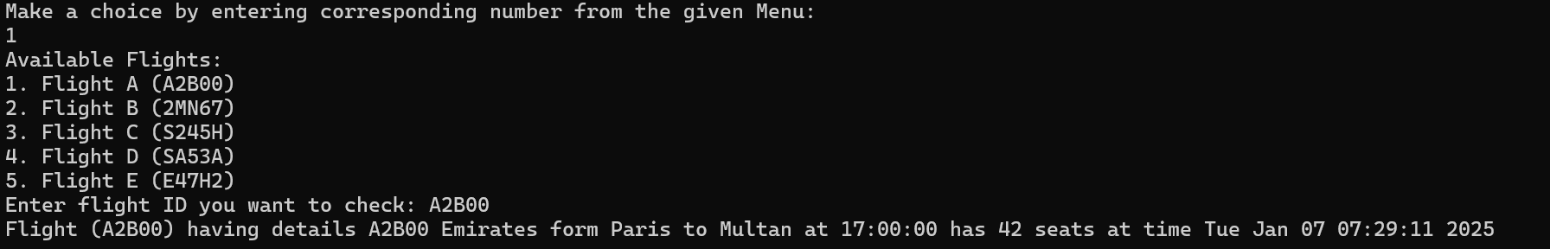

Booking Management:

Purpose: It displays available flights and user selects his flight and confirm bookings with instant ticket generation.
- Function: bookseat ( ) ,availableFlights ( ),time (0),rand ( )
- File Handling: File name is “reservations.txt”
- Arrays: flightID []
Process:
- It prompts to ask user his name and FlightID (display available flights through availableFlights() function.
) he wants to book seat in.
- Also used time (0) and time_t to have current time.
- Also used rand ( ) to generate random seat number.
- Then used loop to check if entered FlightID matches with one in array, if it does, it gives a message that seat is reserved with user’s name and current time and adds this information in “reservations.txt” file.
- Then using this information, generates a ticket.
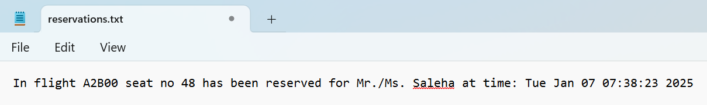
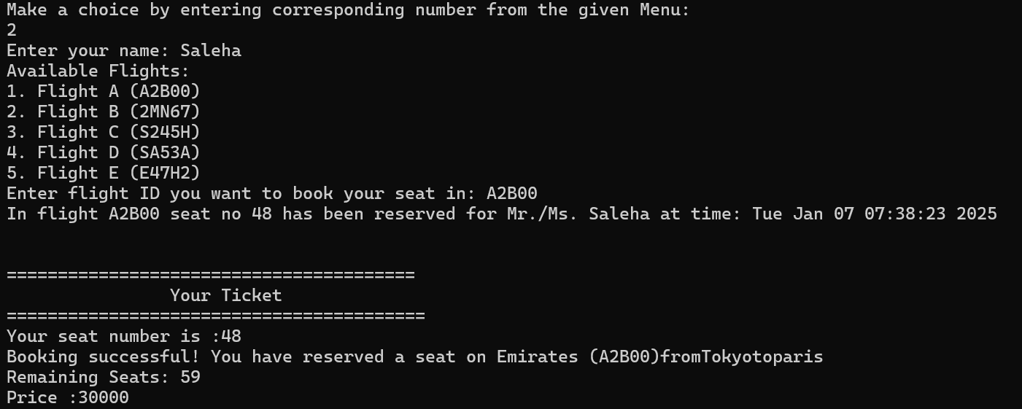
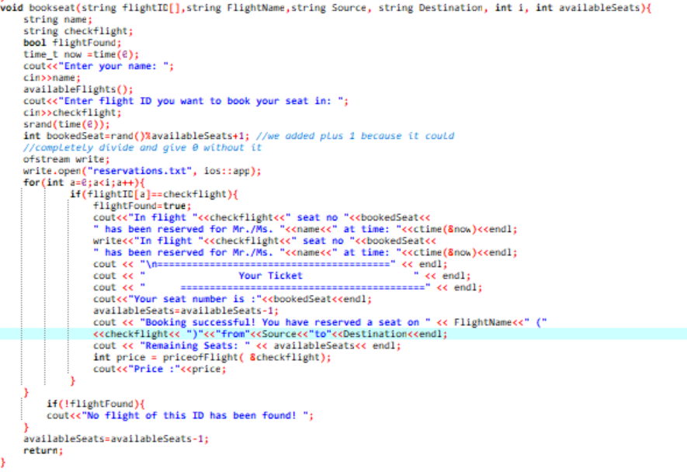

Check Flight Status:
Purpose: The purpose of checking flight status is to inform passengers about their flight's current condition.
- Functions: checkstat ( ), rand ( ),time (0);
Process:
- It prompts to ask user FlightID of flight of which he wants to check status of.
- Then the entered FlightID is matched with available Flights, if it matches , it prompts delay by using rand ( ) to give random minutes and time_t and time(0) to give current time.
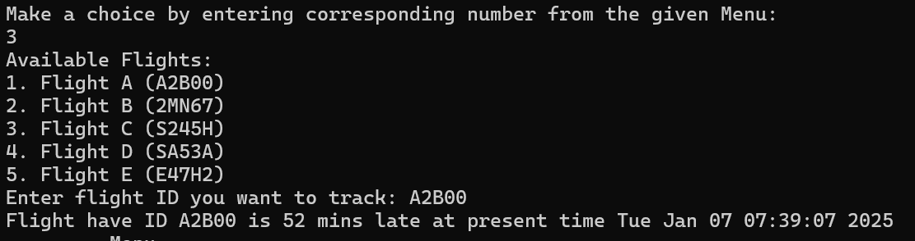
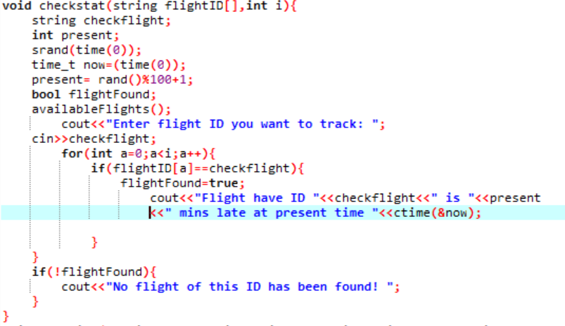

Boarding Pass Generation:
Purpose: The purpose of generating a boarding pass is to provide passengers with essential flight details and authorization to board the plane.
- Function: boarding ( )
Process:
- boarding ( ) function is called in main ( ) function through switch when user selects it
- It gives information of passenger such as name, FlightID, Flight name , destination,source and seat number.
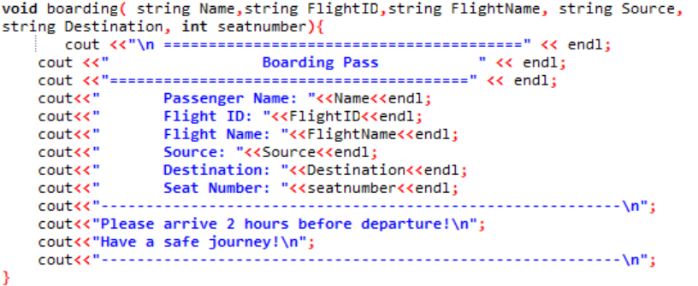
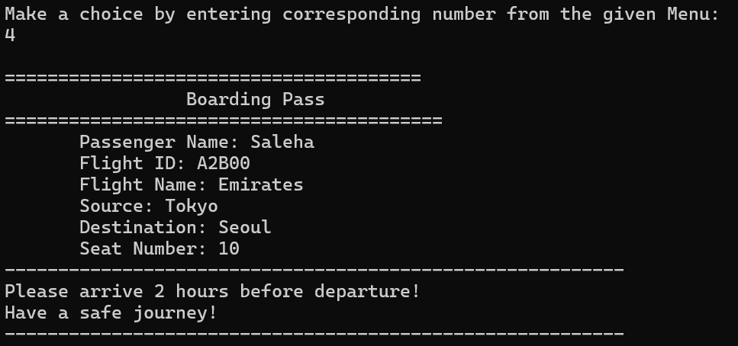

Cancel Booking:
Purpose: The purpose is to cancel a booking. The user can have a change of mind so he would want to cancel his booking.
- Functions: cancelBooking ( ), remove ( ), rename ( )
- File Handling: Files are “reservations.txt”, “temp_res.txt”.
Process:
- The user is asked about FlightID of the flight he wants to cancel booking of.
- The user is asked his username too.
- Then flight is taken from file “reservations.txt”, if the entered FlightID matches with it then it gives prompts that booking has been cancelled.
- Then “reservations.txt” is deleted through remove () and “temp_res.txt” is renamed as “reservations.txt”.
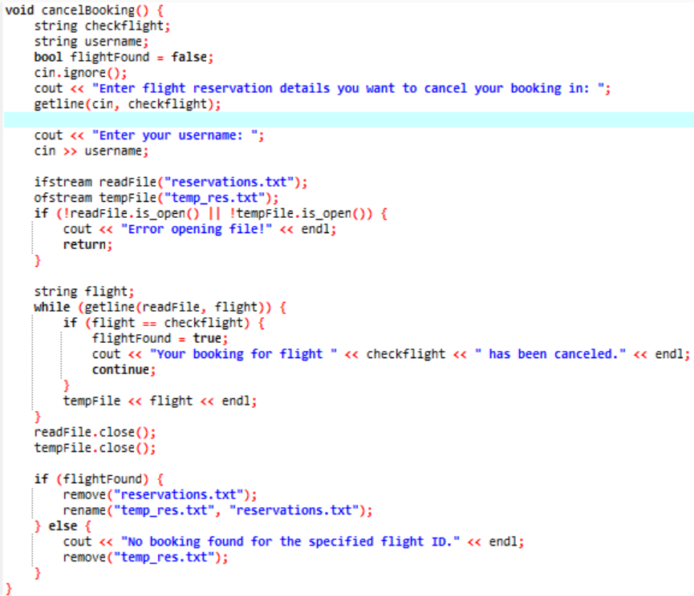

Admin’s Interface:

Menu:
cout<<"---------Menu---------\n";
cout<<"1. Add Flight\n";
cout<<"2. Update Flight\n";
cout<<"3. Delete Flight\n";
cout<<"4. Manage Seat Availibilty\n";
cout<<"5. Send Confirmation Email\n";
cout<<"6. Exit\n";
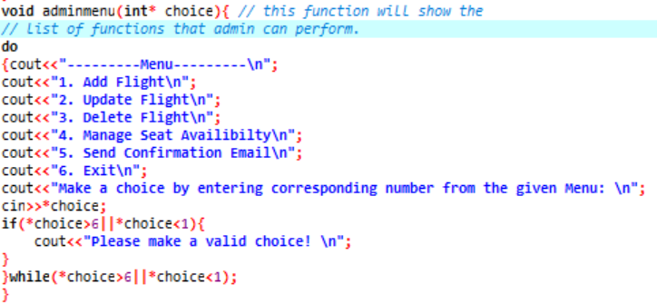
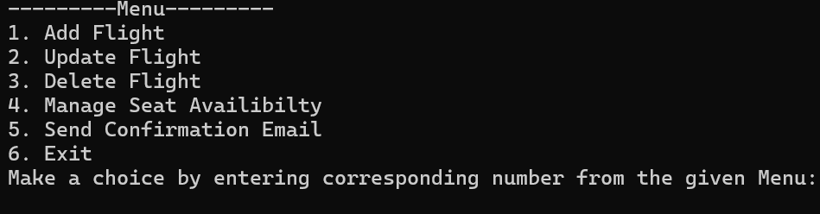

Add Flight:
Purpose: The purpose of adding a flight for an admin is to update the system
with new flight information, ensuring that passengers have access to the latest travel options.
- Functions:
- File Handling: Files are “total flights.txt”, “flight name.txt”, “destination.txt", “source.txt”
Process:
- It prompts to ask user details like flightID of the new flight,flight name , destination and source, and stores this information the files given above respectively.
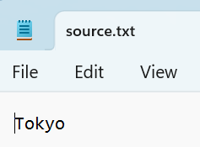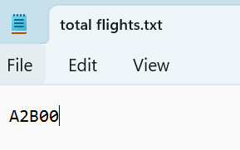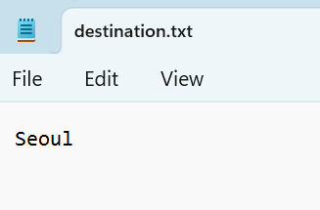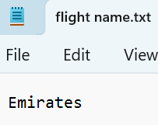
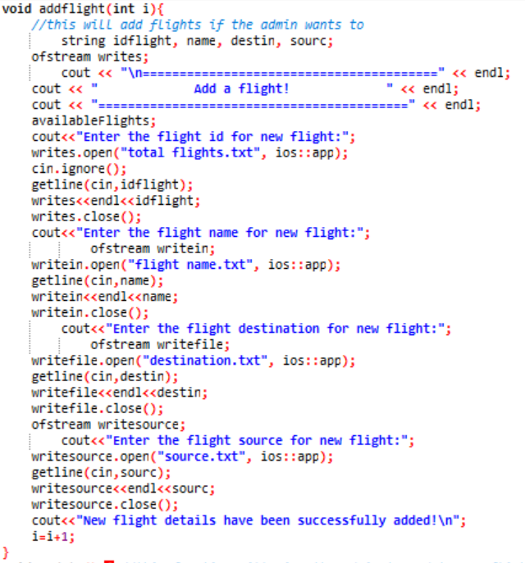
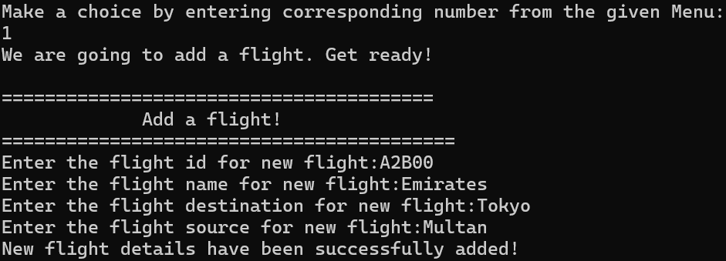


Update a Flight:
Purpose: The purpose is to update some information of a flight if some information is needed to change for example the destination of flight is updated.
- Functions: update ( )
- File Handling: Files are “total flights.txt”, "flight name.txt", "destination.txt", "source.txt", "schedule.txt", "temp_flights.txt", "temp_flight_names.txt", "temp_destinations.txt", "temp_sources.txt", "temp_schedules.txt"
Process:
- The admin is asked the FlightID of the flight he wants to update.
- When admin enters the Flight ID, all permanent files like “total flights.txt”, "flight name.txt", "destination.txt", "source.txt", "schedule.txt" are opened.
- If FlightID admin entered matches with the ones in “total flights.txt” so the program opens temporary files.
- The admin is asked to enter new information and this information is then stored in temporary files "temp_flights.txt", "temp_flight_names.txt", "temp_destinations.txt", "temp_sources.txt", "temp_schedules.txt".
- Then we use remove to delete permanent files and rename the temporary files and store them.
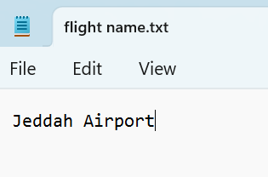
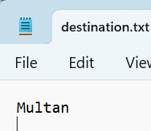
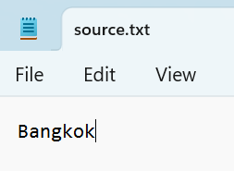
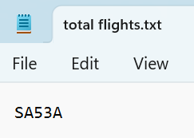

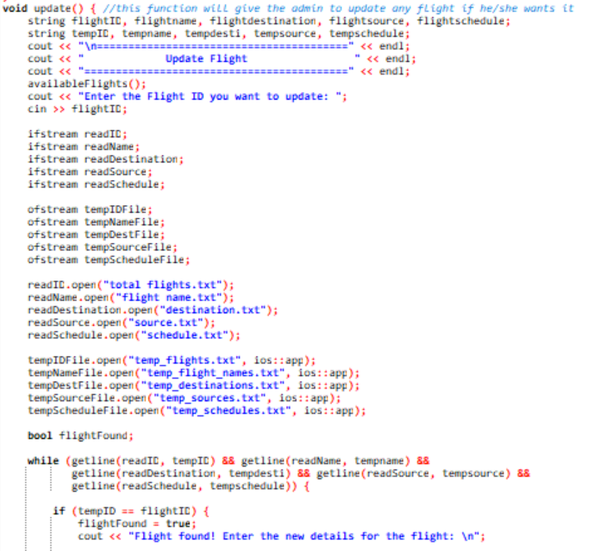
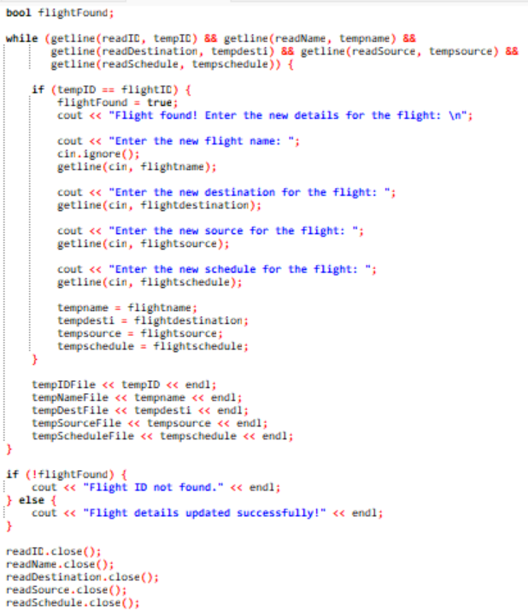
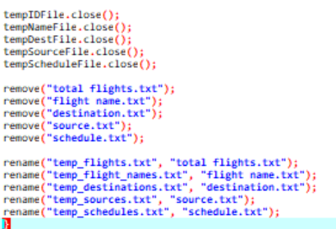
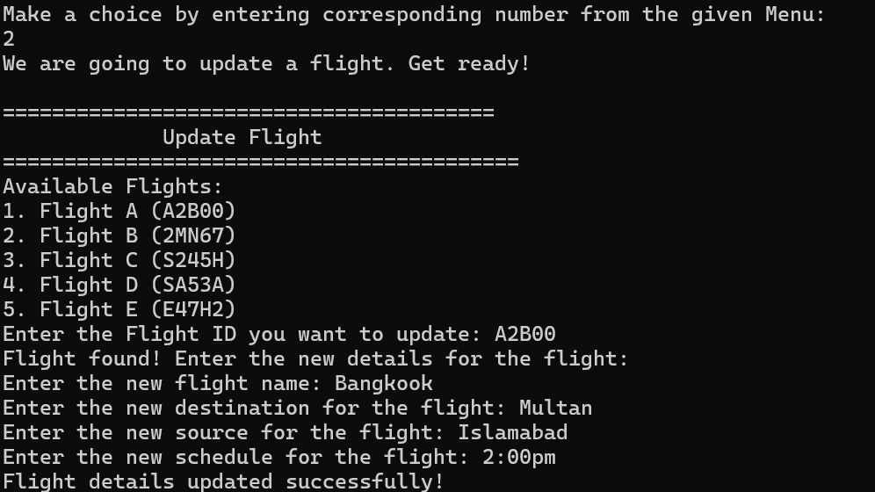

Delete a Flight:
Purpose: The purpose of deleting a flight for an admin is to remove outdated or canceled flights from the system, keeping the flight schedule accurate and organized.
- Functions: deleteFlight ( )
- File Handling: Files are “total flights.txt”, "flight name.txt", "destination.txt", "source.txt", "schedule.txt", "temp_flights.txt", "temp_flight_names.txt", "temp_destinations.txt", "temp_sources.txt", "temp_schedules.txt".
Process:
- It is the same process as update ( ) but we just don’t write new data.
- Then we use remove to delete permanent files and rename the temporary files and store them.
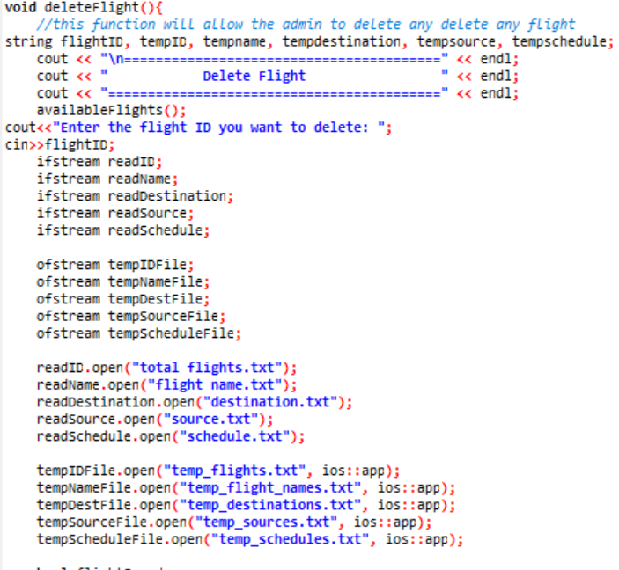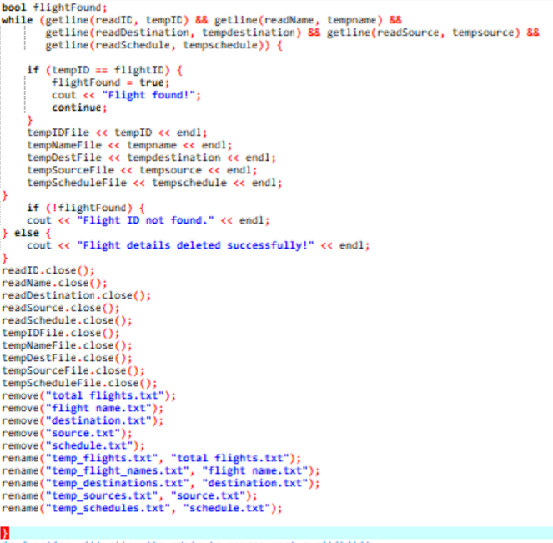
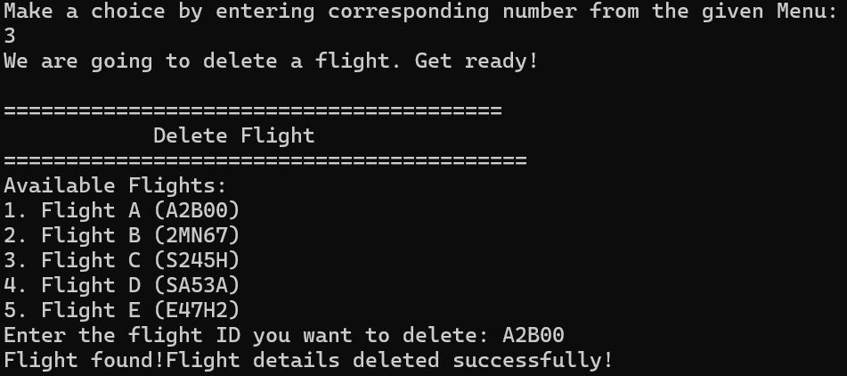

Manage Seat Availability:
Purpose: The purpose of this is that admin can check seat availability, book a seat or cancel a seat.
Menu:
cout<<"1. Check availability\n
2.Book Seat.\n
3.Cancel Booking\n4.Exit\n";
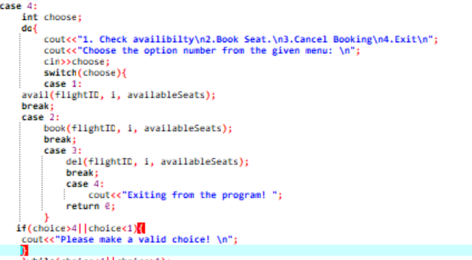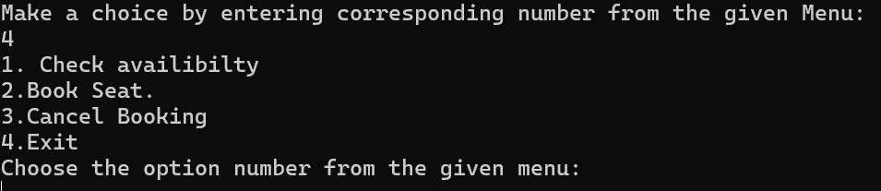
- Functions: avail ( ), book ( ), del ( ), remove ( ), rename ( )
- Arrays; flightID[]
Process:
- First we get into first function avail () that checks availability of seats, the program prompts to ask admin about flightID if it matches with flightID[] array then it displays the number of available seats at current time through time(0) and time_t.
- Then in book ( ) function, same process repeats but the difference is that reserved seat number is generated through rand ( ) and then displayed with current time.
- In del ( ), the same process repeats but the difference is the admin is asked about seat number he wants to cancel and then it is cancelled and number of available seats are increased by 1.
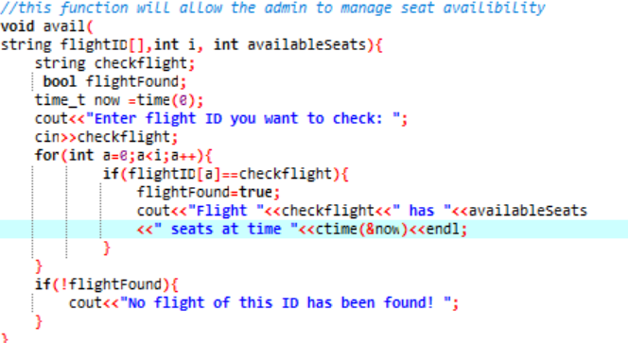
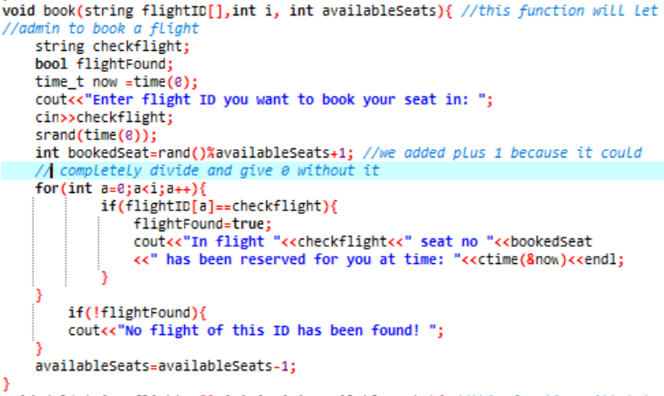
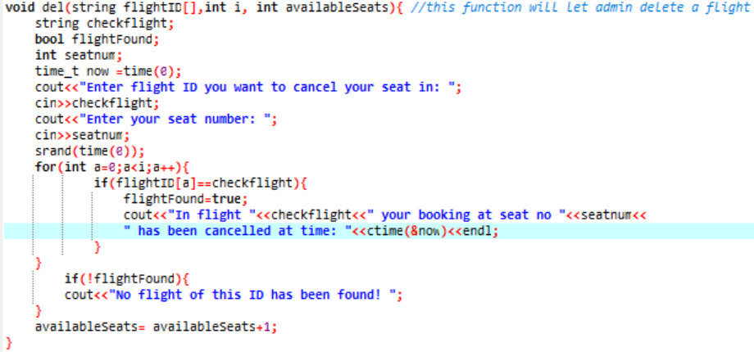
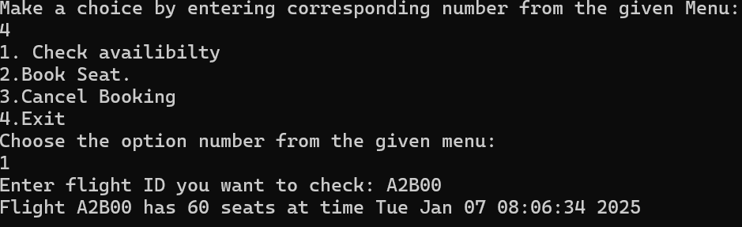
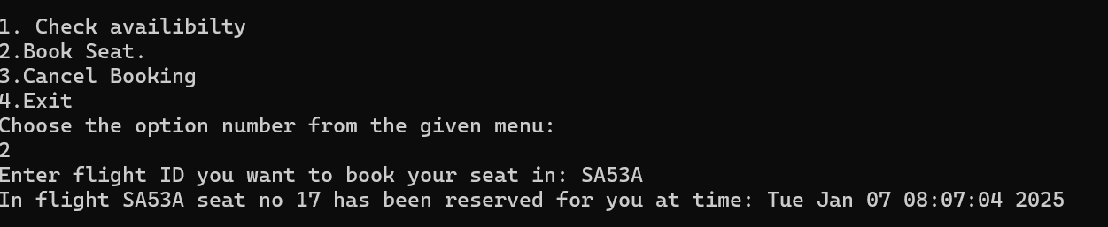
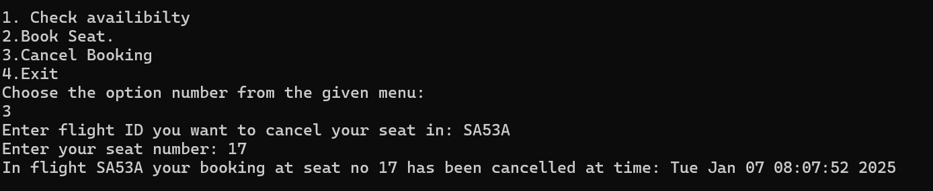

Send Confirmation Email:
Purpose: The purpose of sending confirmation email is that user have a proof of his reservation and booking details.
Process:
- We just prompted that Email has been sent.
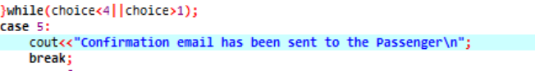
Arrays :
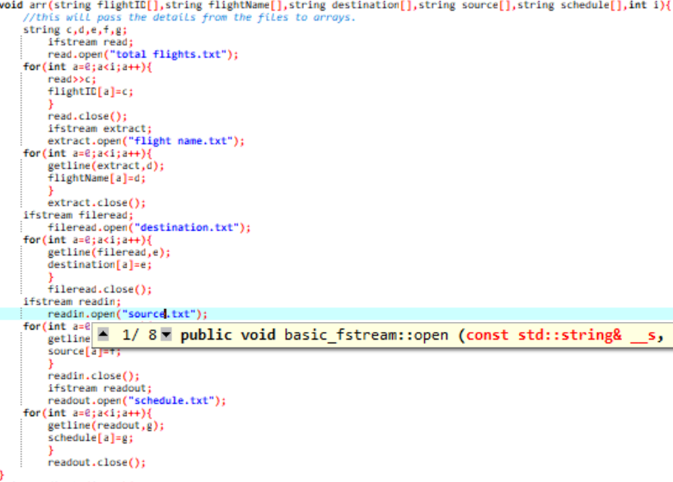

Conclusion and Future Work
Conclusion:
Our Flight Reservation System has successfully met its objectives. The system allows users to check available flights details, book at ticket, check flight status and generate boarding pass. Similarly, it allows admins to log in, add, update, delete, manage seat availability and display confirmation email message. It also stores user data, flight schedulesa and reservations. It provides a secure environment and user-friendly interface.
Future Work:
In this version, many improvements can be made such as real-time flight tracking, dealing with dynamic pricing, manage seat categories, payment gateways, enhanced security features, email sending, feedback system etc.

References:
- https://www.youtube.com/@CodeWithHarry
- https://www.w3schools.com/
- Course Slides
- "A Survey of C++ Programming Language Features and Libraries"
- GitHub - AmanBariar01/Airline-Reservation-System: C++ Project
Link Of Report
https://drive.google.com/drive/folders/1olUbtEaUC7LJ-42z38bcyGmFIN8_0Axx

